**Smile Maker**

**Statement of Purpose**

The main purpose of this application is to make people laugh whenever they open this application and they are capable of adding and editing their own jokes. The application is completely user friendly to make people to use and secured with login authentication in order to secure his own data while he/she is adding or editing their own jokes.

**Objective**

This app shows up a joke every time when the user opens it. The user can login, submit and edit a joke as it's a user-friendly app. It is multi-responsive and easy to handle. Smile maker is the android application, that helps to see the joke which are loaded from the public API. One custom API which will be used to add or edit his/her own jokes using his/her login. Users can also like/dislike the jokes by giving his/her comments on it using a custom API. We also make sure that a used joke will not be displayed often for a particular user because we are using a public API that generates random jokes on every hit. Moreover, we are storing the ID of the joke in order to make sure in the worst cases the joke should not be repeated.

## Functional Requirements

#### Login/Signup page

1. Required User name password as mandatory.
2. Login button to process or validate the user’s name and password.
3. Skip login button to navigate to home screen for skipping the signup process.

#### Home Page

1. Contain a joke which will refresh on new page load.
2. Refresh button to load new joke.
3. More joke button to navigate to all jokes.
4. Add new joke to for the sign in user to add new joke.

#### Header

1. Home page logo which can navigate to the home screen.
2. More jokes link is used to navigate to the more jokes pages.
3. Add new joke link will appear when user login in to the application.
4. Account details link will be used to navigate to the accounts page, this link will be enabled when user sign in only.

#### Account Details Page

1. Edit button to make the details edits.
2. Can enable user to edit username.
3. Change password to update password.
4. Can change the email address and submit.

#### Add New Joke

1. Make user to add joke.
2. User can select the soke to be displayed as anonymous or display user name
3. Enter new joke.
4. Submit button to submit joke.

## Entities

### User

- Email

- Password

- CreatedOn

- Gender

- UserType

- UserName

- Name

### Jokes-API

- UserName

- DateOfSubmit

- Joke_Text

- IsActive

- Name

### ER Diagram

[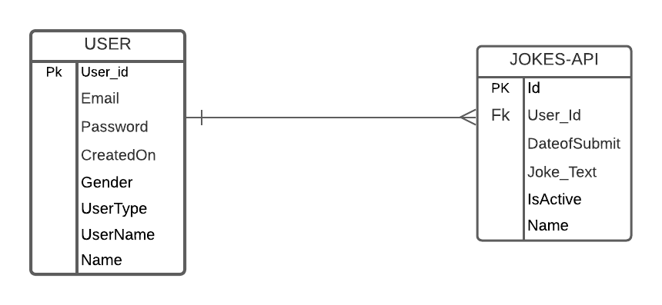](https://github.com/giridhar196/smile-maker/blob/main/images/ER_Diagram.png)

### Logo Sample

[](https://github.com/giridhar196/smile-maker/blob/main/images/Logo_Sample.png)

### Mockup Screen

[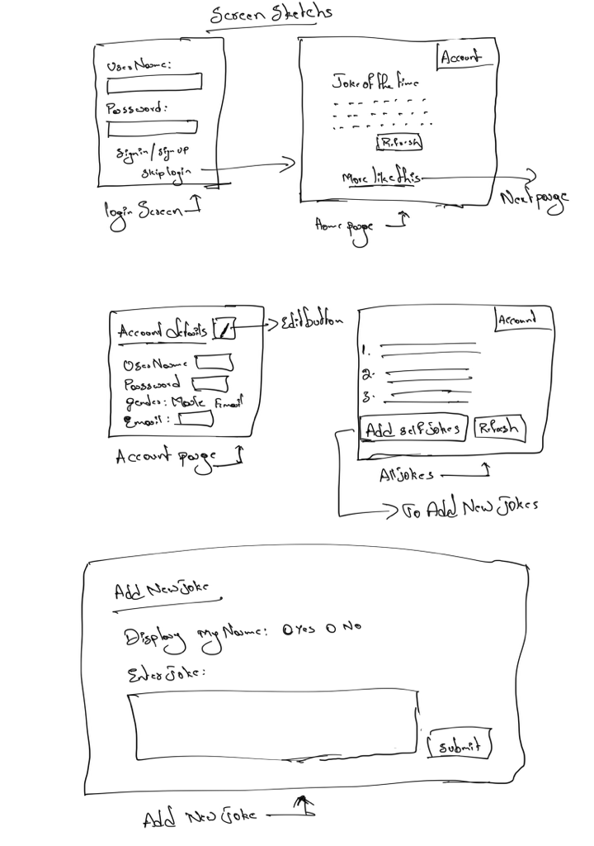](https://github.com/giridhar196/smile-maker/blob/main/images/FunctionalScreens.png)

Team Members

1. Manoj Nuvvala
2. Sai Satyanarayana Gullapalli
3. Alekya Billakanti
4. Sai Kiran Enugala